**EXP 3** 210701201

**Map Reduce program to process a weather dataset.**

**Aim:**

To implement MapReduce program to process a weather dataset

**Procedure:**

**Step 1: Create Data File:**

Create a file named "word_count_data.txt" and populate it with text data that you wish to analyse.

Login with your hadoop user.

# Download the dataset (weather data)

Output:

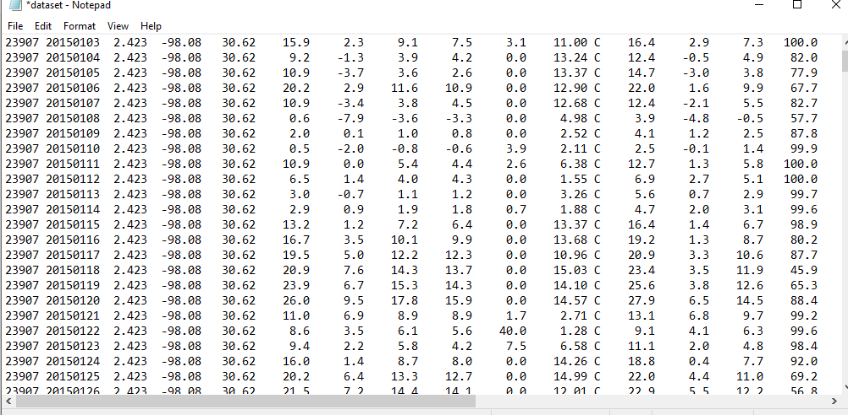

# Step 2: Mapper Logic - mapper.py:

Create a file named "mapper.py" to implement the logic for the mapper. The mapper will read input data from STDIN, split lines into words, and output each word with its count.



#!/usr/bin/env python import sys

# input comes from STDIN (standard input)

# the mapper will get daily max temperature and group it by month. so output will be (month,dailymax_temperature)

for line in sys.stdin:

# remove leading and trailing whitespace line = line.strip()

# split the line into words words = line.split()

#See the README hosted on the weather website which help us understand how each position represents a column

month = line[10:12] daily_max = line[38:45] daily_max = daily_max.strip() # increase counters

for word in words:

# write the results to STDOUT (standard output);

# what we output here will be go through the shuffle proess and then # be the input for the Reduce step, i.e. the input for reducer.py

#

# tab-delimited; month and daily max temperature as output print ('%s\t%s' % (month ,daily_max))

.

# Step 3: Reducer Logic - reducer.py:

Create a file named "reducer.py" to implement the logic for the reducer. The reducer will aggregate the occurrences of each word and generate the final output.



# reducer.py

#!/usr/bin/env python

from operator import itemgetter import sys

#reducer will get the input from stdid which will be a collection of key, value(Key=month , value= daily max temperature)

#reducer logic: will get all the daily max temperature for a month and find max temperature for the month

#shuffle will ensure that key are sorted(month) current_month = None

current_max = 0 month = None

# input comes from STDIN for line in sys.stdin:

# remove leading and trailing whitespace line = line.strip()

# parse the input we got from mapper.py month, daily_max = line.split('\t', 1)

# convert daily_max (currently a string) to float try:

daily_max = float(daily_max) except ValueError:

# daily_max was not a number, so silently # ignore/discard this line

continue

# this IF-switch only works because Hadoop shuffle process sorts map output # by key (here: month) before it is passed to the reducer

if current_month == month:

if daily_max > current_max: current_max = daily_max

else:

if current_month:

# write result to STDOUT

print ('%s\t%s' % (current_month, current_max)) current_max = daily_max

current_month = month

# output of the last month

if current_month == month:

print ('%s\t%s' % (current_month, current_max))

# Step 4: Prepare Hadoop Environment:

Start the Hadoop daemons and create a directory in HDFS to store your data.



# Step 6: Make Python Files Executable:

Give executable permissions to your mapper.py and reducer.py files.



# Step 7: Run the program using Hadoop Streaming:

Download the latest hadoop-streaming jar file and place it in a location you can easily

access.

Then run the program using Hadoop Streaming. hadoop fs -mkdir -p /weatherdata

hadoop fs -copyFromLocal /home/sx/Downloads/dataset.txt /weatherdata hdfs dfs -ls /weatherdata

hadoop jar /home/sx/hadoop-3.2.3/share/hadoop/tools/lib/hadoop-streaming-3.2.3.jar \

-input /weatherdata/dataset.txt \

-output /weatherdata/output \

-file "/home/sx/Downloads/mapper.py" \

-mapper "python3 mapper.py" \

-file "/home/sx/Downloads/reducer.py" \

-reducer "python3 reducer.py"

hdfs dfs -text /weatherdata/output/* > /home/sx/Downloads/outputfile.txt

|  |
| --- |
| jbdkb |
| ouOutput: |

# Step 8: Check Output:

Check the output of the program in the specified HDFS output directory.

**OUTPUT:**

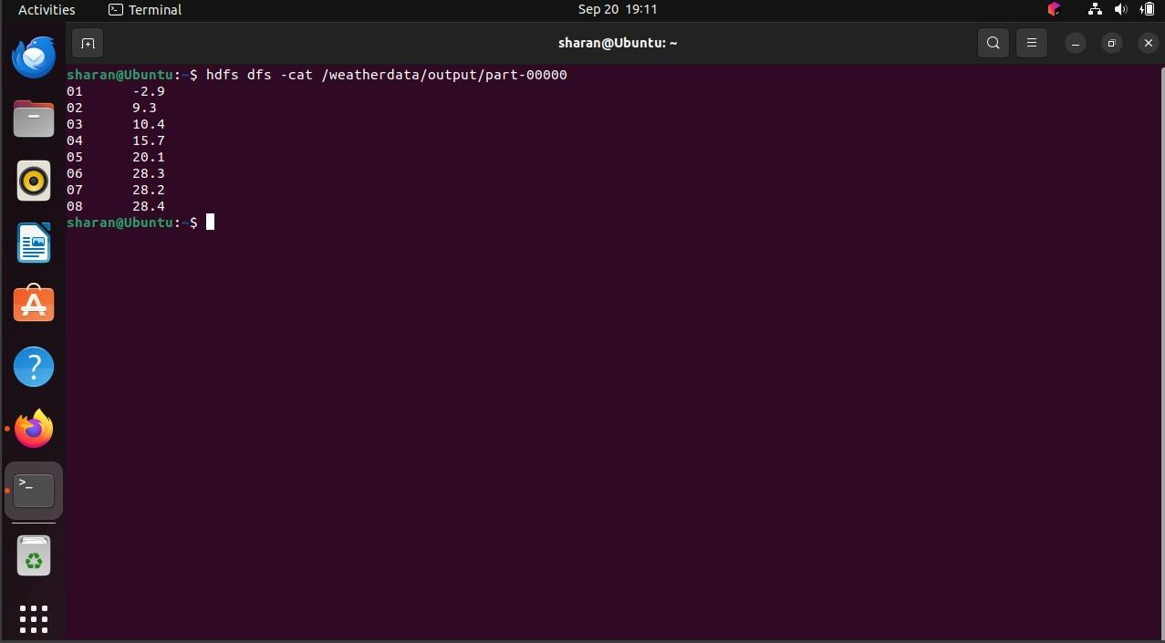

**Result:**

Thus, the program for weather dataset using Map Reduce has been executed successfully.